 COMSATS University Islamabad, Lahore

FALL 2020
□ Sessional-1 □ Sessional-II □ Terminal Examination
Course Title: | Semantic Web (Theory) |  |  |  | Course Code: |  | CSE344 | Credit Hours: | 3(2,1)
Course Instructor/s: | Sana Rizwan |  |  |  | Program Name: |  | BSSE
Semester: | 7th | Batch: | FA17 | Section: | B |  | Date:
Time Allowed: | 1 Hour 15 minutes |  |  |  | Maximum Marks: |  |  | 40
Student’s Name: |  |  |  |  | Reg. No.
Important Instructions / Guidelines:
- Rewriting and cuttings are not allowed. All questions are compulsory.

Question 1: (Marks = 20)

Solve Multiple Choice Questions:
1. In RDF schema, Type(?c,Container)??Type(?c,Resource) shows that all the containers are
- Resources
- Classes
- Properties
- Literals
2. The most general class in RDF Schema is
- class
- property
- literal
- resource
3. One of the limitations of RDFS is unable to restrict number of values a property can take due to lack of
- disjointness of classes
- Boolean combination of classes
- Cardinality restrictions
- Special characteristics of properties
4. In RDF Schema, the functional symbol for empty list in auxiliary list is
- Nil
- list(a)
- item(y,a)
- rest(a)
5. In RDF, the real-life objects or things are called
- statements
- properties
- resources
- tags
6. In RDFS, reified statement shows the class of
- all properties
- all reified statements
- all statements
- all resources
7. Using reification technique in RDF, the object part of statement can be accessed by
- rdf:subject
- rdf:statement
- rdf:description
- rdf:object
8. Graph that can contain both multiple edges and loops between its vertices.
- Multi graph
- Directed graph
- Labeled graph
- Bi-directional graph
9. All resources in RDF are identified with a URI and denoted by the short form _______________of the namespace mechanism that is inherited from XML.
- prefix : foaf
- prefix : localname
- prefix : dc
- prefix : rdfs
10. ________________is an instance of rdf property that will show an instance of one or more classes.
- rdfs:domain
- rdfs:range
- rdfs:Class
- rdfs:Resource
11. rdf:first is an instance of rdf property that can be used to build descriptions of lists and other list-like structures.
- rdf:nil
- rdf:resource
- rdf:first
- rdf:rest
12. The resource rdf:nil is an instance of rdf list that can be used to represent an empty list or other list-like structure.
- rdf:nil
- rdf:resource
- rdf:List
- rdf:rest
13. _:x is __________________________ in the given turtle notation.

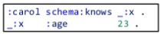

14. If we want to replace rdf:_1, rdf:_2, rdf:_3 with some other property, what would be the particular one in the given RDF code

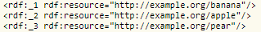
- rdf:_bag
- rdf:_li
- rdf:_seq
- rdf:_collection
15. Which microformat will use to add details of student’s first_name, Last_name, address, Tel no. and CNIC no. etc.
- hCalender
- vCalender
- hCard
- vCard
16. In Rdfa use of vocab tag is

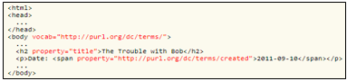
- Single element for chunk of HTML
- Single vocabulary for chunk of HTML
- Double line coding for HTML
- Multi line coding translator
17. If an RDF vocabulary has been defined by a community for some purpose, that vocabulary cannot be directly reused by RDFa publishers
- True
- False
18. GRDDL defines a way to delete the necessary attributes to a dialect of XHTML files, simplifying the task of authors.
- True
- False
19. GRDDL processor execute each transformation collectively and perform an RDF merge on the generated graphs, yielding the result.
- True
- False
20. If we want to replace rdf:li with some appropriate property in sequence, select the particular one.

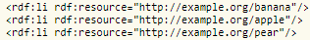
- rdf:_last
- rdf:_front
- rdf:_1, rdf:_2, rdf:_3
- rdf:nil

Question 2: (Marks = 20)

Part 1: (Marks = 4)

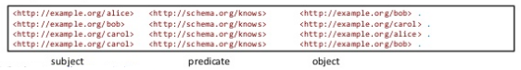
Show N-triple representation in Turtle notation with proper format.
1. Prefix____________________________________________________
2. Prefix ____________________________________________________

3. Alice bob ________________________________________________
4. Bob carol _________________________________________________
5. Carol bob _________________________________________________
6. Carol alice _________________________________________________

Part 2: (Marks = 3)

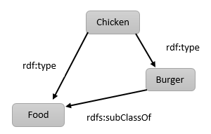

Write down RDFS inference with IF, AND, THEN clause.

IF: ___________________________________

AND:_________________________________

THEN:_________________________________

Part 3: (Marks = 6)

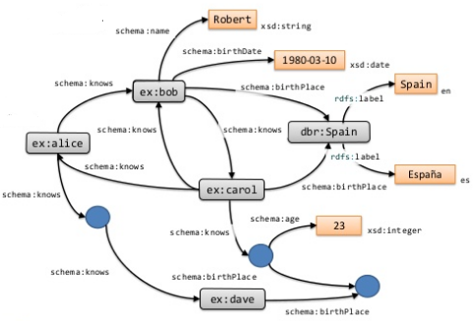
A. Write 5 Literal values.
1. _____________________________________
2._____________________________________
3. _____________________________________
4. _____________________________________
5._____________________________________
B. represents _________________________.
C. xsd:integer is __________________ in ______________________Language.

Part 4: (Marks = 5)

Consider the given graph to find reflexive and transition property for RDF with “abc” as PREFIX.

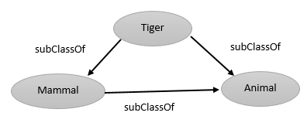
Reflexive property:
1. Tiger: ____________________________________________________
2. Animal: ___________________________________________________

Transitive Property:
3. If __________________________________________________________
And __________________________________________________________
Then__________________________________________________________

Part 5: (Marks = 2)

1. What you can infer to get domain:

ts: hasFriend rdfs:domain ts:Person.
tsgroup:tim ts:hasFriend tsgroup:Clinp.

2. What you can infer to get range:

ts: hasFriend rdfs:range ts:Person.
tsgroup:tim ts:hasFriend tsgroup:Clinp.

THE END

Solution
Question 1: (Marks = 20)

Solve Multiple Choice Questions:
1. In RDF schema, Type(?c,Container)??Type(?c,Resource) shows that all the containers are
- Resources
- Classes
- Properties
- Literals
Answer:a

2. The most general class in RDF Schema is
- class
- property
- literal
- resource
Answer: D

3. One of the limitations of RDFS is unable to restrict number of values a property can take due to lack of
- disjointness of classes
- Boolean combination of classes
- Cardinality restrictions
- Special characteristics of properties
Answer: C

4. In RDF Schema, the functional symbol for empty list in auxiliary list is
- Nil
- list(a)
- item(y,a)
- rest(a)
Answer: A

5. In RDF, the real-life objects or things are called
- statements
- properties
- resources
- tags
Answer: C

6. In RDFS, reified statement shows the class of
- all properties
- all reified statements
- all statements
- all resources
Answer: B

7. Using reification technique in RDF, the object part of statement can be accessed by
- rdf:subject
- rdf:statement
- rdf:description
- rdf:object
Answer: D

8. Graph that can contain both multiple edges and loops between its vertices.
- Multi graph
- Directed graph
- Labeled graph
- Bi-directional graph
Answer: A

9. All resources in RDF are identified with a URI and denoted by the short form _______________of the namespace mechanism that is inherited from XML.
- prefix : foaf
- prefix : localname
- prefix : dc
- prefix : rdfs
Answer: B

10. ________________is an instance of rdf property that will show an instance of one or more classes.
- rdfs:domain
- rdfs:range
- rdfs:Class
- rdfs:Resource
Answer: A

11. rdf:first is an instance of rdf property that can be used to build descriptions of lists and other list-like structures.
- rdf:nil
- rdf:resource
- rdf:first
- rdf:rest
Answer: C

12. The resource rdf:nil is an instance of rdf list that can be used to represent an empty list or other list-like structure.
- rdf:nil
- rdf:resource
- rdf:List
- rdf:rest
Answer: A

13. _:x is __________________________ in the given turtle notation.

Answer: blank node

14. If we want to replace rdf:_1, rdf:_2, rdf:_3 with some other property, what would be the particular one in the given RDF code

- rdf:_bag
- rdf:_li
- rdf:_seq
- rdf:_collection
Answer: B

15. Which microformat will use to add details of student’s first_name, Last_name, address, Tel no. and CNIC no. etc.
- hCalender
- vCalender
- hCard
- vCard
Answer:D

16. In Rdfa use of vocab tag is

- Single element for chunk of HTML
- Single vocabulary for chunk of HTML
- Double line coding for HTML
- Multi line coding translator
Answer: B

17. If an RDF vocabulary has been defined by a community for some purpose, that vocabulary cannot be directly reused by RDFa publishers
- True
- False
Answer: B

18. GRDDL defines a way to delete the necessary attributes to a dialect of XHTML files, simplifying the task of authors.
- True
- False
Answer: B

19. GRDDL processor execute each transformation collectively and perform an RDF merge on the generated graphs, yielding the result.
- True
- False
Answer: B
20. If we want to replace rdf:li with some appropriate property in sequence, select the particular one.


- rdf:_last
- rdf:_front
- rdf:_1, rdf:_2, rdf:_3
- rdf:nil
Answer: C

Question 2: (Marks = 20)

Part 1: (Marks = 4)


Show N-triple representation in Turtle notation with proper format.
1. Prefix____________________________________________________
2. Prefix ____________________________________________________

3. Alice bob ________________________________________________
4. Bob carol _________________________________________________
5. Carol bob _________________________________________________
6. Carol alice _________________________________________________

Solution:
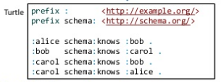

Part 2: (Marks = 3)


Write down RDFS inference with IF, AND, THEN clause.

IF: ___________________________________

AND:_________________________________

THEN:_________________________________

Solution:
IF: chicken rdf:type Burger
AND: Chicken rdfs:subClassOf Food
THEN: Chicken rdf:type Food

Part 3: (Marks = 6)


A. Write 5 Literal values.
1. _____________________________________
2._____________________________________
3. _____________________________________
4. _____________________________________
5._____________________________________
B. represents _________________________.
C. xsd:integer is __________________ in ______________________Language.

Solution:
A. 1. Robert
2. 1980-03-10
3. Spain
4. Espana
5. 23

B. blank nodes
C. datatype, XML

Part 4: (Marks = 5)

Consider the given graph to find reflexive and transition property for RDF with “abc” as PREFIX.


Reflexive property:
1. Tiger: ____________________________________________________
2. Animal: ___________________________________________________

Transitive Property:
3. If __________________________________________________________
And __________________________________________________________
Then__________________________________________________________

Solution:
Reflexive property:
1. Tiger: abc:Tiger rdfs:subClassOf abc:Tiger
2. Animal: abc:Animal rdfs:subClassOf abc:Animal
Transitive Property:
3. IF abc:Tiger rdfs:subClassOf abc:Mammal
And abc:Tiger rdfs:subClassOf abc:Animal
Then abc:Mammal rdfs:subClassOf abc:Animal

Part 5: (Marks = 2)

1. What you can infer to get domain:

ts: hasFriend rdfs:domain ts:Person.
tsgroup:tim ts:hasFriend tsgroup:Clinp.

2. What you can infer to get range:

ts: hasFriend rdfs:range ts:Person.
tsgroup:tim ts:hasFriend tsgroup:Clinp.

Solution:
1. What you can infer to get domain:
ts: hasFriend rdfs:domain ts:Person.
tsgroup:tim ts:hasFriend tsgroup:Clinp.
Answer:
tsgroup: tim rdf:type ts:Person.

2. What you can infer to get range:
ts: hasFriend rdfs:range ts:Person.
tsgroup:tim ts:hasFriend tsgroup:Clinp.
Answer:
tsgroup: tim rdf:type ts:Person.
THE END

